Make the following modification to the Menu app we just build.
- Add a EditText for the user to enter a URL.
- Place the button on the right of the EditText and rename to “submit.”
- Add another button beneath the EditText and name it to ”bookmark.”
- On clicking the submit button, the URL should be displayed in the WebView.
- On clicking the bookmark button, the current URL should be saved as a bookmark.
- The menu for the app now should display a list of saved bookmarks.
- On selecting a saved bookmark, the corresponding webpage should be displayed.

This homework is kind of a basic browser where we can browse the website and bookmark it and these bookmarks are saved and when we click on the saved bookmarks the same page will reload without having to type the URL again and again.

MainActivity.java : This is the primary application class that features a bookmark-enabled browser. The application launches and configures "EditText" and "WebView" to show webpages and allow users to enter URLs. It also features a submit button that, when pressed, loads the URL from "EditText" into "WebView." Furthermore, there is a bookmark button on it. Clicking this button while on a loaded webpage saves the URL of the webpage in the bookmark’s menu, which is located on the action bar and has a "+" sign. When a bookmark is selected from this menu, the relevant webpage loads into the "WebView."

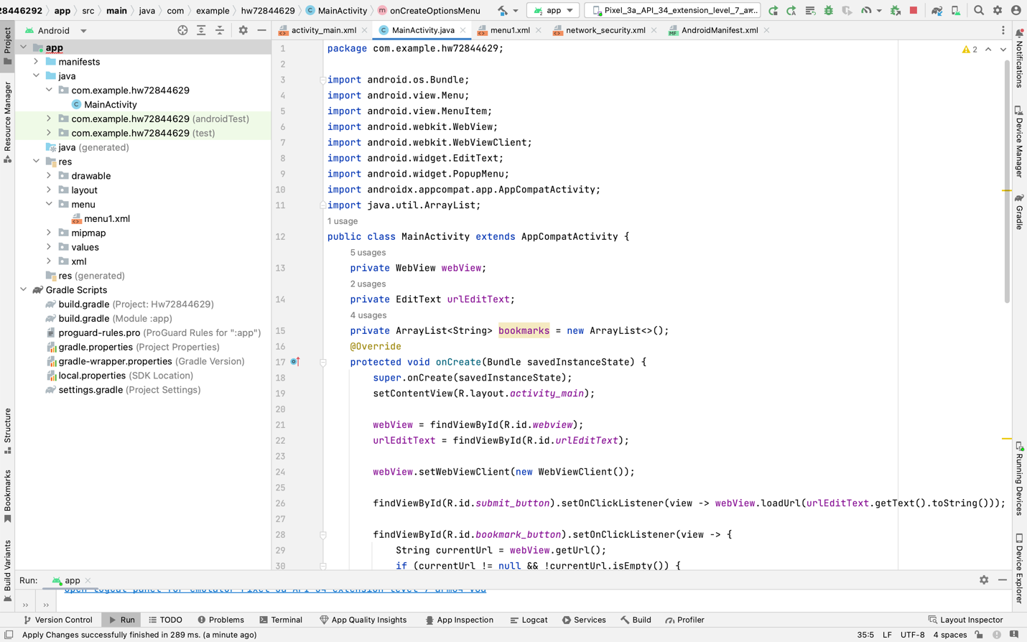

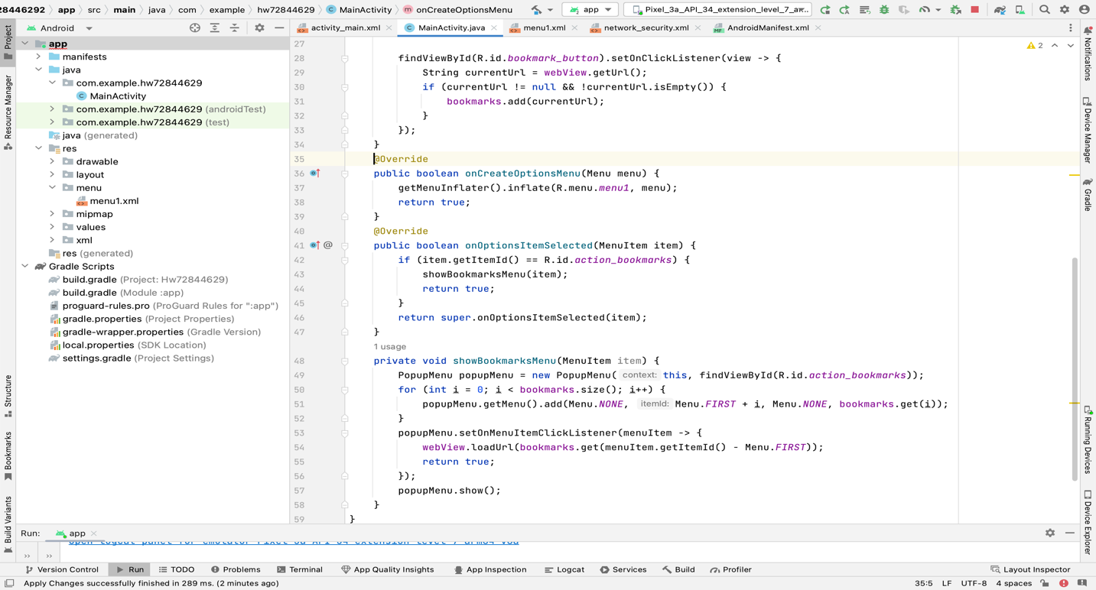

Activity_main.xml : This defines the user interface for the app. we are using “RelativeLayout” for this app for organizing the elements to be position relative to teach other for the clean and functional design.it has a ”EditText” for users to enter web address, a “Submit” button to load the entered URL and a “Bookmark” button to save the current page with a “WebView” to display the web content.

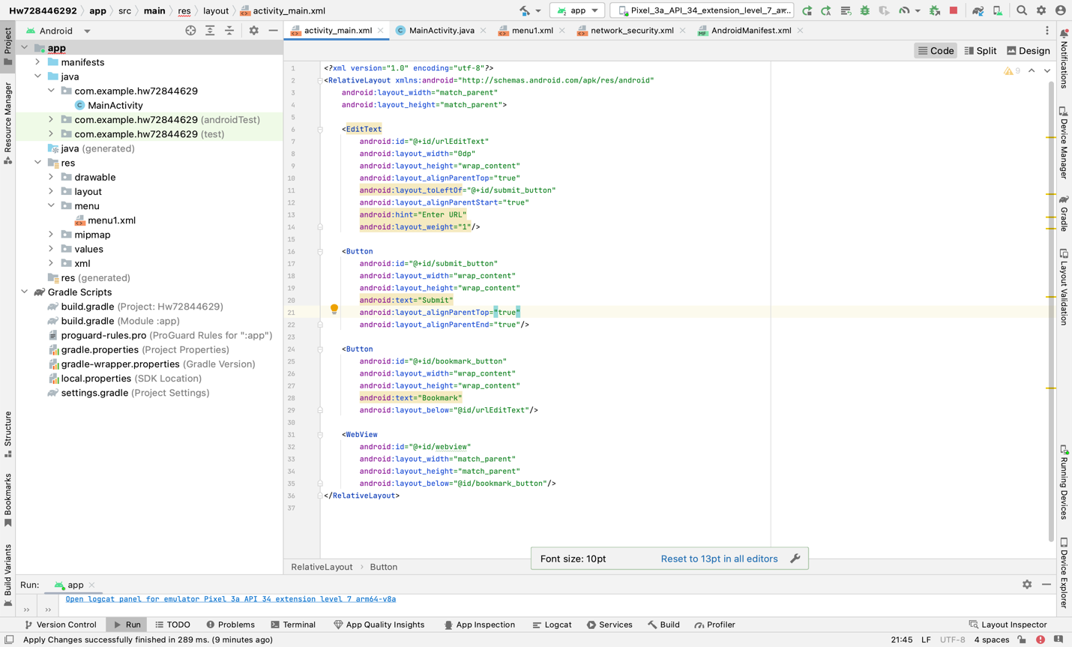
Menu1.xml : This is the menu layout for the app for adding a menu item for bookmarks. To ensure that menu resources are correctly categorized and processed by the Android build system, separate from layout resources. .The main menu item is identifying as “action_bookmarks” which is titled as “Bookmarks” and uses a default android icon “ic_menu_add”.to ensure that the bookmark menu directly appear. On the apps action bar for displaying both the item and the text we are using the attribute “app:showAsACtion = “ifRoom|withText””.

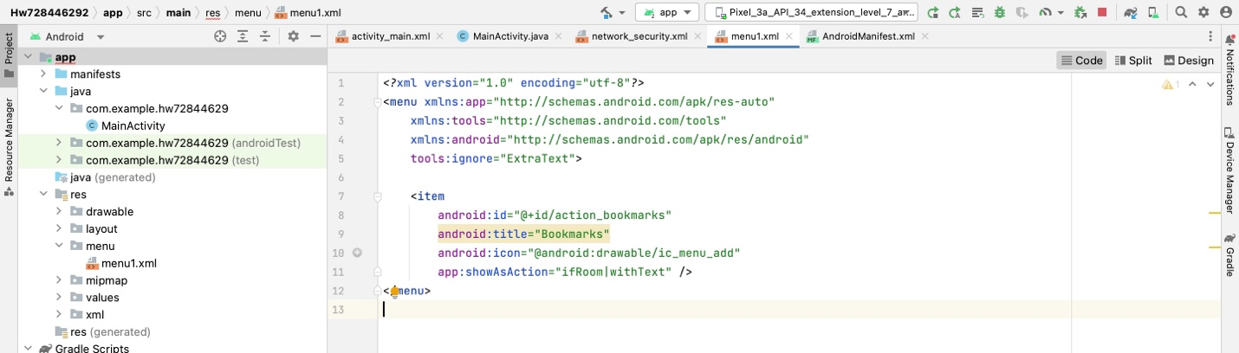

Network_security.xml :this is the network security : this is necessary for the android apps targeting SDK version 28 or higher due to enhance security measures that blocks non-Https network traffic by default. This configuration allows us to specify security settings for our apps network communication such as permitting cleartext traffic. We have to declare this in android manifest to work.

Note: as I updated my android studio, I was encountering error for using SDK below 33 or 34 so I must use the network security configuration.

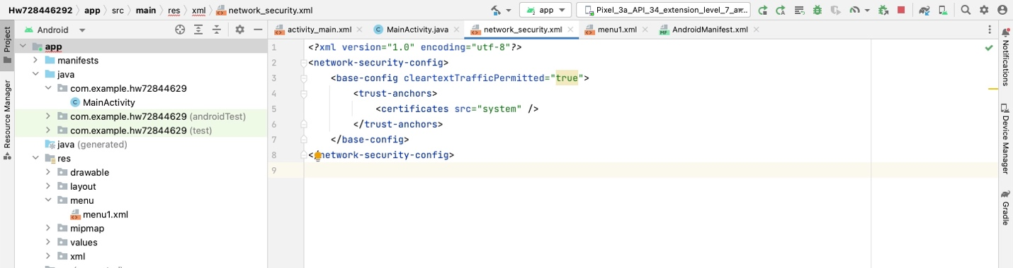

Below are the screenshots of the app :

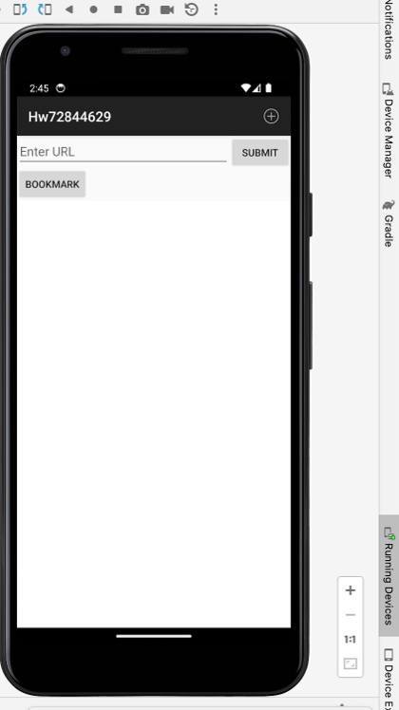
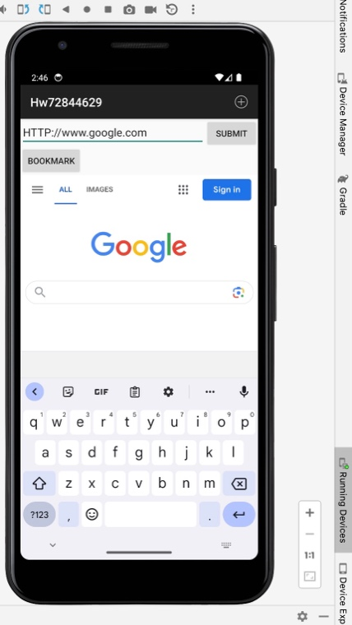
Screenshot(MainActivity). Screenshot(entering the input and clicking on submit)

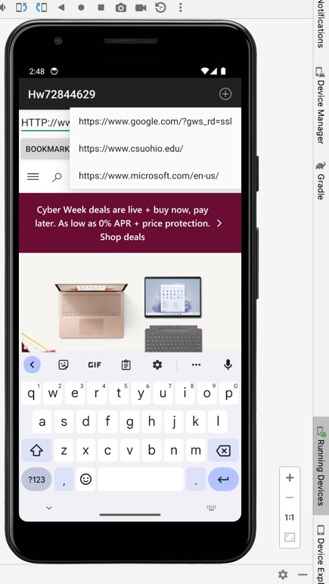
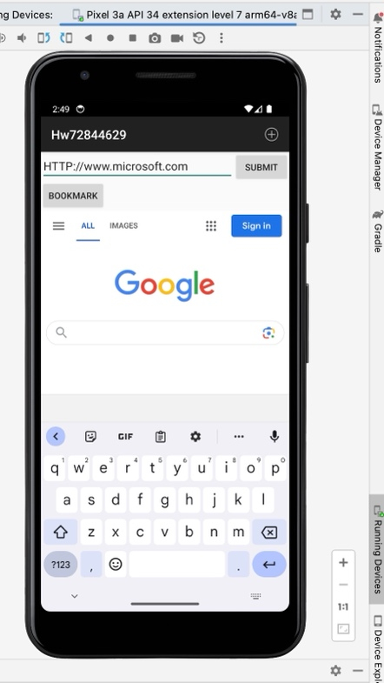
Screenshot3(saved bookmarks). Screenshot4(reloading page from saved bookmarks)

